**Hello Team!** **Consider the below two tables**:

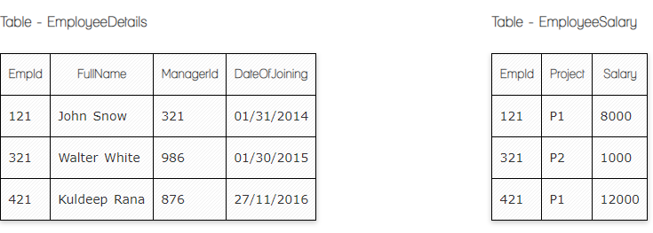

**Ques.1. Write a SQL query to fetch the count of employees working in project 'P1'.**

**Your Answer:**

SELECT count(EmpId),Project FROM EmployeeSalary where Project='P1'

**Ques.2. Write a SQL query to fetch employee names having salary greater than or equal to 5000 and less than or equal 10000.**

**Your Answer:**

SELECT EmployeeDetalis.EmpId, EmployeeDetalis.FullName, EmployeeSalary.Salary FROM EmployeeDetalis

Inner join EmployeeSalary on EmployeeDetalis.EmpId = EmployeeSalary.EmpId Where Salary between 5000 and 10000

**Ques.3. Write a SQL query to fetch count of employees sorted by project's count in descending order.**

**Your Answer:**

SELECT Project, count(EmpId) FROM EmployeeSalary Group By Project order by count(EmpId) desc

**Ques.4. Write a query to fetch employee names and salary records. Return employee details even if the salary record is not present for the employee.**

**Your Answer:**

SELECT EmployeeDetalis.FullName, EmployeeSalary.Salary FROM EmployeeDetalis

Left join EmployeeSalary on EmployeeDetalis.EmpId = EmployeeSalary.EmpId

**Ques.5. Write a SQL query to create an empty table with ‘Test’ name.**

**Your Answer:**

CREATE TABLE Test (  
   );

**Ques.6. Write a SQL query to delete an empty table with ‘Test’ name.**

**Your Answer:**

DROP TABLE  Test;

**Ques.7. Write a SQL query to fetch all the Employees details from EmployeeDetails table who joed in Year 2016.**

**Your Answer:**

SELECT * FROM EmployeeDetalis

Left join EmployeeSalary on EmployeeDetalis.EmpId = EmployeeSalary.EmpId

where DateOfJoining Like '%2016%';

**Ques.8. Write a SQL query to insert new record to the EmployeeDetails table with any data.**

**Your Answer:**

Insert into EmployeeDetalis (FullName,ManagerId,DateOfJoining)

values ('Armine Melqonyan','555','01/05/2023');

**Ques.9. Write a SQL query to update EmployeeSalery table with setting Salary to 2000 for Project P2.**

**Your Answer:**

UPDATE  EmployeeSalary

SET Salary = 2000 WHERE Project='P2';

**Ques.10. Write a SQL query to right join both tables and draw the results.**

**Your Answer:**

SELECT * FROM EmployeeDetalis

Right join EmployeeSalary on EmployeeDetalis.EmpId = EmployeeSalary.EmpId;

**Now take these two tables:**

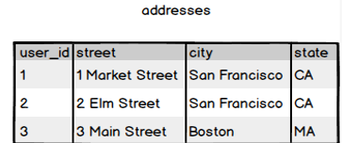

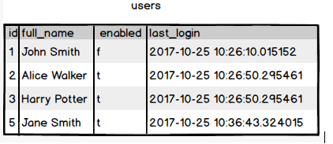

**Ques.11. Write a SQL query to fetch all users full_name from San Francisco.**

**Your Answer:**

SELECT users.full_name

FROM users

Right join addresses on users.id = addresses.user_id

Where city='San Francisco';

**Ques.12. Write a SQL query to fetch all users full_name, last_login who are enabled**

**Your Answer:**

SELECT users.full_name, last_login

FROM users Where enabled='t';

**Ques.13. Write a SQL query to fetch all users full_name who are not from Main street**

**Your Answer:**

SELECT users.full_name

FROM users

Inner join addresses on users.id = addresses.user_id Where not street='Main Street';

**Ques.14. Write a SQL query to fetch all users full_name who are from Main street or San Francisco**

**Your Answer:**

SELECT users.full_name

FROM users

Inner join addresses on users.id = addresses.user_id Where street='Main Street' or city= 'San Francisco'

**Ques.15. Write a SQL query to fetch user full_name who is equal to user_id from Boston (find user_id value in sub_query)**

**Your Answer:**

SELECT full_name

FROM users

WHERE id=(SELECT user_id FROM addresses WHERE city=’Boston’)